### MAJOR PROJECT REPORT

On

### *“*Development of an automated prediction model of skin abnormalities from photographic images*”*

*Submitted in partial fulfillment of the requirements for the award of*

### Bachelor of Technology (B.Tech)

In the department of

### Computer Science & Engineering

### 

*Submitted by*:

### Soumik Das (UG/02/BTCSE/2020/040)

*Under the Guidance of*

### Dr. Jhilam Mukherjee

### Assistant Professor

### Dept. Of CSE

### Adamas University

**School of Engineering & Technology**

**ADAMAS University, Kolkata, West Bengal**

**Jan 2024 – June 2024**

**CERTIFICATE**

This is to certify that the project report entitled ***“*Development of an automated prediction model of skin abnormalities from photographic images*”****,* submitted to the School of Engineering & Technology (SOET), **ADAMAS UNIVERSITY, KOLKATA** in partial fulfillment for the completion of **Semester – 8th** of the degree of **Bachelor of Technology** in the department of **Computer Science & Engineering**, is a record of bonafide work carried out by **Soumik Das**, **UG/02/BTCSE/2020/040.,** under our guidance.

All help received by us from various sources have been duly acknowledged.

No part of this report has been submitted elsewhere for award of any other degree.

**________________________**

**Dr. Jhilam Mukherjee**

**(Project Guide)**

**______________________**

**Mr. Sayantan Singha Roy / Mr. Aninda Kundu**

**(Project Coordinator)**

**_____________________**

**Dr. Sajal Saha**

**(HOD CSE)**

### ACKNOWLEDGEMENT

The satisfaction and euphoria that accompany the successful completion of any task would be incomplete without the mentioning of the people whose constant guidance and encouragement made it possible. I take pleasure in presenting before you, my project, which is the result of a studied blend of both research and knowledge.

I express my earnest gratitude to our **Dr. Jhilam Mukherjee (Project Guide)**, **Department of CSE**, for their constant support, encouragement and guidance. I am grateful for their cooperation and valuable suggestions.

Finally, I express my gratitude to all other members who are involved either directly or indirectly for the completion of this project.

## DECLARATION

I, the undersigned, declare that the project entitled ‘Development of an automated prediction model of skin abnormalities from photographic images’, being submitted in partial fulfillment for the award of Bachelor of Engineering Degree in Computer Science & Engineering, affiliated to ADAMAS University, is the work carried out by me.

_____________________

**Soumik Das**

**(UG/02/BTCSE/2020/040)**

**ABSTRACT**

Accurate and timely detection of high-risk skin abnormalities, particularly melanomas, is crucial for effective treatment and improved patient outcomes. In this study, we propose an innovative approach that combines the powerful feature extraction capabilities of XceptionNet with the interpretability provided by Explainable Artificial Intelligence (XAI), specifically the Gradient-weighted Class Activation Mapping (Grad-CAM) model.

XceptionNet, known for its deep learning prowess in image recognition tasks, is employed to analyze a diverse dataset of skin lesion images encompassing malignant and benign cases. By leveraging the Xception architecture, we harness its ability to capture intricate features indicative of high-risk abnormalities.

Moreover, we integrate XAI techniques, particularly Grad-CAM, to provide visual explanations for the model's predictions. Grad-CAM generates heatmaps highlighting regions within the input images that significantly influence the classification decision, thereby enhancing the interpretability of the model's output.

Through rigorous experimentation and evaluation, our results demonstrate the effectiveness of the combined XceptionNet and Grad-CAM approach in accurately detecting high-risk skin abnormalities. Furthermore, the interpretability afforded by Grad-CAM empowers dermatologists to understand and validate the model's decisions, thereby fostering trust in its diagnostic capabilities.

This study represents a significant advancement in computer-aided diagnosis systems for dermatology, offering not only high accuracy in detection but also transparency and interpretability through XAI techniques. The integration of XceptionNet with Grad-CAM holds promise for improving early diagnosis, guiding treatment decisions, and ultimately enhancing patient care in the field of dermatology. Future research may explore additional XAI methods and their integration into clinical practice to further augment diagnostic accuracy and confidence.

**TABLE OF CONTENTS**

|  |  |  |
| --- | --- | --- |
| **CHAPTER** | **TITLE** | **PAGE** |
|  | **TITLE PAGE** | i |
|  | **CERTIFICATE** | ii |
|  | **ACKNOWLEDGEMENT** | iii |
|  | **DECLARATION** | iv |
|  | **ABSTRACT** | v |
|  | **TABLE OF CONTENTS** | vi |
|  | **LIST OF FIGURES** | ix |
|  | **LIST OF TABLES** | x |
|  | **LIST OF EQUATIONS** | xi |
|  | **ACRONYMS** | xii |
| **1** | **INTRODUCTION** | 1-4 |
|  | 1.1 Background | 1 |
|  | 1.2 Purpose of the project | 2 |
|  | 1.3 Problem Statement | 3 |
|  | 1.4 Objective | 3 |
|  | 1.5 Structure of project | 4 |
| **2** | **LITERATURE REVIEW** | 5-11 |
|  | 2.1 Terminologies related to skin cancer | 5 |
|  | 2.2 Literature review of some of the previous reports | 8 |
| **3** | **TECHNOLOGY** | 12-19 |
|  | **3.1 Data Augmentation Technique** | 12 |
|  | **3.2 XceptionNet Architecture** | 13 |
|  | 3.3 Explainable AI (XAI) | 15 |
|  | 3.4 Performance Matrices | 17 |
|  | 3.4.1 Confusion Matrix | 17 |
|  | 3.4.2 Accuracy | 18 |
|  | 3.4.3 Specificity | 18 |
|  | 3.4.4 Sensitivity | 19 |
|  | 3.4.5 ROC Curve | 19 |
| **4** | **METHEDOLOGY** | 20-22 |
|  | 4.1 Data Collection | 20 |
|  | 4.2 Data Augmentation | 21 |
|  | 4.3 Model Implementation | 22 |
| **5** | **OUTPUT** | 23-27 |
|  | 5.1 Visual verification of the predicted results | 23 |
|  | 5.2 Performance Analysis | 24 |
|  | **CONCLUSION** | 28 |
|  | **FUTURE WORK** | 29 |
|  | **REFERENCE** | 30 |
|  | **PLAGARISM REPORT** | 32 |

**LIST OF FIGURES**

|  |  |  |
| --- | --- | --- |
| **FIGURE** | **TITLE** | **PAGE** |
| Fig 1.1 | Early Sign of Skin Cancer | 2 |
| Fig 2.1 | Melanoma Skin Cancer | 6 |
| Fig 2.2 | Basal Cell Carcinoma | 6 |
| Fig 2.3 | Squamous Cell Carcinoma | 7 |
| Fig 3.1 | **XceptionNet Architecture** | 15 |
| Fig 3.2 | Confusion Matrix Diagram | 17 |
| Fig 4.1 | Benign Image | 20 |
| Fig 4.2 | Malignant Image | 20 |
| Fig 4.3 | Augmented Images | 21 |
| Fig 4.4 | Block Diagram of the Model | 22 |
| Fig 5.1 | Visual verification of the predicted results | 23-24 |
| Fig 5.2 | Confusion Matrix of XceptionNet model on 80/20 Dataset | 25 |
| Fig 5.3 | ROC Curve of XceptionNet model on 80/20 Dataset | 26 |
| Fig 5.4 | Results of Grad-CAM | 27 |

**LIST OF TABLES**

|  |  |  |
| --- | --- | --- |
| **TABLE** | **TITLE** | **PAGE** |
| Table 5.1 | Performance Analysis of different models on 80/20 dataset | 24 |
| Table 5.2 | Performance Analysis of XceptionNet model on dataset | 25 |

**LIST OF EQUATIONS**

|  |  |  |
| --- | --- | --- |
| **EQUATION** | **TITLE** | **PAGE** |
| Equation 3.1 | CAM computing equation | 16 |
| Equation 3.2 | **Importance weights** computing equation | 16 |
| Equation 3.3 | **Heatmap** computing equation | 16 |
| Equation 3.4 | **Accuracy** computing equation | 18 |
| Equation 3.5 | **Specificity** computing equation | 18 |
| Equation 3.6 | **Sensitivity** computing equation | 19 |
| Equation 3.7 | **True positive rate** computing equation | 19 |
| Equation 3.8 | **False positive rate** computing equation | 19 |

**ACRONYMS**

|  |  |  |
| --- | --- | --- |
| **Sl. No.** | **ACRONYMS** | **FULL FORM** |
| **1** | Grad-CAM | Gradient-weighted Class Activation Mapping |
| **2** | XAI | Explainable Artificial Intelligence |
| **3** | BCC | Basal Cell Carcinoma |
| **4** | SCC | Squamous Cell Carcinoma |
| **5** | ABCD rule | Asymmetry (A), Border (B), Color (C) and Diversity (D) |
| **6** | GLCM | Gray-Level Co-occurrence Matrix |
| **7** | HOG | Histogram of Oriented Gradients |
| **8** | SVM | Support Vector Machine |
| **9** | KNN | K-Nearest Neighbour |
| **10** | CNN | Convolutional Neural Network |
| **11** | VGG | Visual Geometry Group |
| **12** | GAN | Generative Adversarial Network |
| **13** | RDB | Residual Dense Block |
| **14** | LSTM | Long Short-Term Memory |
| **15** | DWT | Discrete Wavelet Transform |
| **16** | LPQ | Local Phase Quantization |
| **17** | LBP | Local Binary Pattern |
| **18** | NCA | Neighborhood Component Analysis |
| **19** | GLRLM | Gray-Level Run-Length Matrix |
| **20** | PSO | Particle Swarm Optimization |
| **21** | FKM | Fuzzy k-means Clustering |
| **22** | ReLU | Rectified Linear Unit |
| **23** | TP | True Positive |
| **24** | TN | True Negative |
| **25** | FP | False Positive |
| **26** | FN | False Negative |
| **27** | TPR | True Positive Rate |
| **28** | FPR | False Positive Rate |
| **29** | ROC | Receiver Operating Characteristic |

**CHAPTER 1**

**INTRODUCTION**

This Section deals about the introduction of our project to build a background of the project and to take a clear idea about the purpose, problem statement, objective and structure of the project.

**1.1 Background:**

Skin cancer refers to the abnormal growth of skin cells, predominantly triggered by exposure to ultraviolet radiation from sunlight or tanning beds. Its primary forms include basal cell carcinoma, squamous cell carcinoma, and melanoma. Basal cell carcinoma typically manifests as a shiny bump or pearly growth, squamous cell carcinoma often appears as a scaly patch or raised lesion, while melanoma presents as an irregularly shaped, pigmented lesion. Although basal and squamous cell carcinomas typically grow slowly and are less likely to metastasize, melanoma poses a significant risk of spreading to other parts of the body if not detected early. Risk factors for skin cancer include sun exposure, family history, fair skin, and a weakened immune system. Early detection through self-examinations and professional screenings is vital, as treatment options, including surgery, radiation, chemotherapy, and immunotherapy, is more effective in the disease's early stages. Preventive measures like sunscreen use and sun protection clothing aid in mitigating risks, highlighting the importance of both detection and prevention strategies in combating skin cancer. Early sign of the skin cancer is shown in Fig 1.1.

Utilizing transfer learning with XceptionNet and explainable AI via Grad-CAM offers a robust framework for high and low-risk skin cancer detection. By leveraging the pre-trained XceptionNet model and fine-tuning it on a dataset of annotated skin lesion images, the model can learn to classify different types of skin cancers while adapting to specific risk levels. Following training, Grad-CAM is employed to generate heatmaps, visually highlighting the regions of the skin lesions that the model focuses on when making predictions. These heatmaps provide clinicians with transparent insights into the model's decision-making process, aiding in interpretation and validation of predictions. This integrated approach not only enhances the accuracy of skin cancer detection but also fosters transparency and interpretability, empowering clinicians to make more informed diagnostic decisions based on both model predictions and clinical insights.

In addition to the technical aspects, the successful deployment of this framework requires careful consideration of several factors. Firstly, a comprehensive and diverse dataset of skin lesion images is crucial for training a robust model capable of accurately detecting various types and risk levels of skin cancer. Moreover, effective preprocessing techniques, such as image resizing, normalization, and augmentation, are essential for optimizing model performance and generalization. Furthermore, collaboration with dermatologists and other healthcare professionals is vital throughout the development process to ensure clinical relevance and validity. Additionally, thorough validation and evaluation of the model's performance on independent test datasets are necessary to assess its effectiveness and reliability in real-world scenarios. Finally, the integration of the model into clinical workflows, along with appropriate training for healthcare practitioners on its interpretation and utilization, is essential for successful implementation and adoption in clinical practice. By addressing these considerations, the combination of transfer learning with XceptionNet and Grad-CAM can serve as a powerful tool for enhancing skin cancer detection and improving patient outcomes.

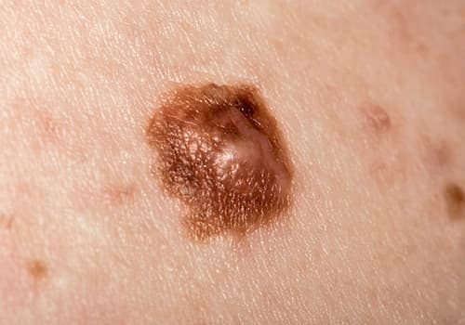

Fig 1.1: Early Sign of Skin Cancer

**1.2 Purpose of the project:**

The purpose of the project focused on high and low-risk skin cancer detection utilizing a transfer learning model like XceptionNet coupled with explainable AI (XAI) techniques such as Grad-CAM is two-fold. Firstly, it aims to develop a highly accurate and robust classification system capable of distinguishing between different types of skin cancers, including both high and low-risk variants, leveraging the power of deep learning and transfer learning. Secondly, the project seeks to enhance the interpretability and transparency of the model's predictions through XAI techniques like Grad-CAM, enabling clinicians to understand the rationale behind the model's decisions and facilitating more informed diagnostic assessments. By combining advanced machine learning algorithms with XAI methods, the project ultimately aims to improve early detection rates, treatment outcomes, and patient care in the realm of skin cancer diagnosis, offering a valuable tool for both clinicians and patients in the fight against this prevalent and potentially life-threatening disease.Top of Form

**1.3 Problem Statement:**

The problem statement for an AI-based mobile application focused on high and low-risk skin cancer detection utilizing transfer learning with XceptionNet and XAI Grad-CAM models is multifaceted. Skin cancer is a widespread and potentially life-threatening condition, with early detection being critical for successful treatment outcomes. However, current methods of detection often rely heavily on human interpretation and may lack accuracy or accessibility, particularly in regions with limited healthcare resources. Therefore, the objective is to develop a mobile application that leverages state-of-the-art AI techniques to provide users with a reliable and user-friendly tool for skin cancer screening. By integrating transfer learning with XceptionNet, the application aims to accurately classify skin lesions into high and low-risk categories, thereby facilitating early detection and intervention. Additionally, the incorporation of XAI Grad-CAM enables transparent visualization of the model's decision-making process, enhancing trust and understanding among users and healthcare providers. Ultimately, the development of such an application addresses the pressing need for accessible, accurate, and interpretable skin cancer detection solutions, potentially saving lives and improving healthcare outcomes on a global scale.

**1.4 Objective:**

The objective of employing a transfer learning model likes XceptionNet in conjunction with explainable AI (XAI) techniques such as Grad-CAM for high and low-risk skin cancer detection is twofold. Firstly, it aims to develop a highly accurate and reliable classification system capable of distinguishing between different types and risk levels of skin cancers. Leveraging transfer learning with XceptionNet allows us to capitalize on the vast knowledge learned from pre-trained models and adapt it to the specific task of skin cancer detection, thereby enhancing the model's performance and generalization capabilities. Secondly, the objective is to enhance the interpretability and transparency of the model's predictions through XAI techniques like Grad-CAM. By providing visual explanations of the regions within skin lesion images that contribute most to the model's decisions, Grad-CAM enables clinicians to understand and trust the model's outputs, facilitating more informed diagnostic assessments and improving patient care. Overall, the objective is to develop a comprehensive and effective tool for skin cancer detection that combines advanced machine learning algorithms with transparent and interpretable AI methods, ultimately contributing to early detection, improved treatment outcomes, and enhanced patient safety.

### 1.5 Structure of the Project:

### The project on high and low-risk skin cancer detection using a transfer learning model like XceptionNet and XAI Grad-CAM involves several key components organized into a structured framework. Firstly, data collection and preprocessing are essential steps where a diverse dataset of annotated skin lesion images is gathered and prepared, ensuring uniformity and quality for model training. Subsequently, the dataset is divided into training, validation, and testing sets to train and evaluate the model's performance effectively. The transfer learning process begins by initializing the XceptionNet model with pre-trained weights on a large-scale dataset such as ImageNet, followed by fine-tuning on the skin cancer dataset to adapt the model to the specific task. Concurrently, XAI techniques like Grad-CAM are integrated into the model to provide interpretable insights into its decision-making process, enhancing transparency and trust. Model evaluation involves rigorous testing on the held-out test set, assessing metrics such as accuracy, precision, recall to gauge performance. Additionally, the project emphasizes collaboration with dermatologists and healthcare professionals for domain expertise and validation of model predictions. Finally, the development of a user-friendly mobile application interface facilitates real-world deployment, enabling users to access the system for skin cancer screening and diagnosis with ease. This structured ensures a comprehensive and effective framework for high and low-risk skin cancer detection, combining advanced machine learning techniques with transparent and interpretable AI methods for improved healthcare outcomes.

**CHAPTER 2**

**LITERATURE REVIEW**

This Section deals on the terminologies and the gives an overview of the previous works related to the project.

**2.1 Terminologies related to skin cancer:**

Skin cancer is a type of cancer that originates in the skin cells. It is characterized by the uncontrolled growth of abnormal skin cells, typically triggered by damage to the DNA of skin cells, often caused by exposure to ultraviolet (UV) radiation from the sun or artificial sources like tanning beds.

There are several types of skin cancer, categorized based on the cells from which they originate. The two main types are melanoma and non-melanoma skin cancers, which include basal cell carcinoma (BCC) and squamous cell carcinoma (SCC).

* **Melanoma:** Melanoma develops in the melanocytes, the pigment-producing cells responsible for melanin production. It is less common than non-melanoma skin cancers but has a higher potential to metastasize (spread) to other parts of the body. Melanomas often appear as asymmetrical moles with irregular borders, varied colors, and a larger diameter referred to Fig 2.1.

**Symptoms:** Melanoma, a type of skin cancer, may exhibit signs following rule: asymmetry, irregular borders, uneven coloring, a diameter larger than a pencil eraser, and evolution (changes in size, shape, color, or elevation). It is crucial to be attentive to moles or lesions that differ significantly from others, known as the "ugly duckling" sign. Melanomas can also present with itching, tenderness, or ulceration, where the lesion breaks through the skin, forming an open sore that may bleed. Early detection is essential for successful treatment, and any suspicious changes in the skin should prompt immediate consultation with a healthcare professional, particularly a dermatologist. Regular skin self-exams and professional skin checks are advised, especially for those with risk factors for skin cancer.

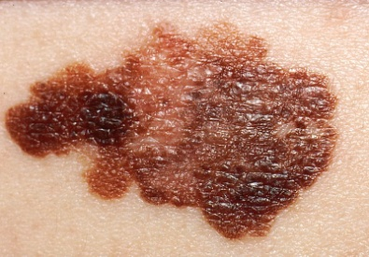

Fig 2.1: Melanoma Skin Cancer

* **Non-Melanoma Skin Cancers:**
* **Basal Cell Carcinoma (BCC):** BCC is the most common type of skin cancer. It tends to grow slowly and is usually localized, with a low risk of spreading to other parts of the body. BCC often appears as a pearly or waxy bump, or a flat, flesh-colored or brown scar-like lesion. Fig 2.2 referred to the Basal Cell Carcinoma.

**Symptoms:** Basal Cell Carcinoma (BCC), the most prevalent form of skin cancer, typically manifests as a slow-growing, shiny or pearly bump, nodule, or growth on sun-exposed areas like the face, head, and neck. The lesion may develop a central ulcer, crust over, bleed easily, or resemble a scar-like or reddish patch on the skin. Some BCCs have a waxy or translucent appearance. While these tumors rarely metastasize, they can invade surrounding tissues if untreated. Early signs often include changes in skin texture, ulceration, and a slow, painless growth. If any of these symptoms are observed, it is crucial to seek prompt medical evaluation, preferably from a dermatologist, for accurate diagnosis and appropriate management. Regular skin self-exams and professional skin checks are recommended for early detection and treatment.

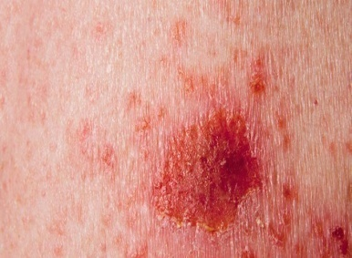

Fig 2.2: Basal Cell Carcinoma

* **Squamous Cell Carcinoma (SCC):** SCC arises in the squamous cells, which are found in the outer layer of the skin. It can metastasize, although less commonly than melanoma, and is associated with a higher risk of spreading than basal cell carcinoma. SCC may appear as a red, scaly patch, an open sore, or a raised growth with a central depression referred to Fig 2.3.

**Symptoms:** Squamous Cell Carcinoma (SCC), a common form of skin cancer, typically presents as a raised, red, scaly patch, a firm and nodular lesion, or an open sore that may crust or bleed. Developing in the squamous cells of the skin, SCC often occurs in sun-exposed areas and can be associated with a history of chronic sun exposure or pre-existing skin conditions. Unlike basal cell carcinoma, SCC has a higher potential to metastasize, although it generally does so less frequently than melanoma. Early symptoms may include changes in the skin, such as the appearance of a persistent sore, rough or scaly growth, or changes in an existing lesion. Any suspicious skin changes should be promptly evaluated by a healthcare professional, preferably a dermatologist, for accurate diagnosis and appropriate treatment. Regular skin self-exams and professional skin checks are important for early detection and management of squamous cell carcinoma.

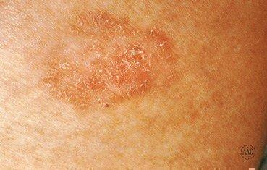

Fig 2.3: Squamous Cell Carcinoma

Apart from these main types, other, less common types of skin cancer include Merkel cell carcinoma, dermatofibrosarcoma protuberans, and cutaneous T-cell lymphoma.

It's important to note that early detection is crucial for effective treatment, and any suspicious changes in the skin should be promptly examined by a healthcare professional. Regular skin self-examinations and professional skin checks are recommended, especially for individuals at a higher risk due to factors such as sun exposure, fair skin, or a family history of skin cancer.

**2.2 Literature review of some of the previous reports:**

As the skin is the body’s largest organ, the point of considering skin cancer as the most common type of cancer among humans is understandable. The critical factor in skin cancer treatment is early diagnosis only. So for the early diagnosis various machine learning and deep learning approaches have been used for computer-based skin cancer detection in recent years.

In paper [1] Automatic detection of skin lesion with ABCD rule, GLCM and HOG are implemented and for the feature extraction and classification different machine learning approaches like SVM, KNN and Naïve Bayes classifier are used to classify skin lesion between benign and melanoma. The classification result obtained is 97.8 % of Accuracy and 0.94 Area under Curve using SVM classifiers. And additionally the Sensitivity obtained was 86.2 % and Specificity obtained was 85 % using KNN.

In paper [2] seven classes of skin lesions have been classified using Resnet-50, VGG-16, Densenet, Mobilenet, Inceptionv3, Xception, and CNN. Finally, the performance of the models is evaluated using evaluation metrics such as precision, recall, f1-score, and accuracy. Among all the models, Inceptionv3 provides the best result, which is 90 % accuracy.

In paper [3] authors propose CNN model with some image pre-processing steps that help to categorize skin lesions with a better classification rate than other existing models. Normalization, data reduction, and data augmentation are used in pre-processing steps to classify benign and malignant cancer lesions from the HAM10000 dataset. From the experimental result, the proposed model gained an accuracy of 96.10% in training and 90.93% during testing. This model reduces the execution time and also performing well-handled.

In paper [4] authors proposed the classification approach for the skin cancer images using different algorithms like VGG16, ResNet, InceptionV3 with the core methodology to modify the input images using the GAN concept of image super resolution and then passing the images in the neural network. They also provided a Residual Dense Network approach for improving the input image resolution, where the basic build component is the residual dense block (RDB). Dense connections between layers in each RDB enable maximum utilization of local layers. A dense residual network completes the simple build module for the ISR. Then the RDN permits the local layers for dense connection among different layers. The global feature fusion methodology is proposed for extracting the hierarchical features. Moreover, the proposed methodology enhances the initial accuracy by 15.59% for VGG16, 13.85% for ResNet and 7.78% for InceptionV3. Thorough benchmark assessments demonstrate that our proposed approach provides dominance over state-of-the-art procedures.

In paper [5] a novel and robust skin cancer detection model was proposed based on features fusion. In the first stage, authors proposed a model that pre-processed the images using a GF filter to remove the noise from the skin images. Then, features were extracted by employing LBP for manual features extraction and Inception V3 for automatic features extraction. Aside from this, an Adam optimizer was utilized for the adjustments of the learning rate. In the end, an LSTM network was utilized on fused features for the classification of skin cancer into two classes: malignant and benign. The skin lesion Dermis dataset available on the Kaggle website, consisting of 1000 images, out of which 500 belong to the benign class and 500 to the malignant class. The proposed methodology attained 99.4% accuracy, 98.7% precision, 98.66% recall, and a 98% F-score. After evaluating the proposed model and compared the performance with existing segmentation-based and DL-based techniques. The results show that the method provided significant results compared to existing techniques.

In paper [6] Multilevel fuse feature generation using Discrete Wavelet Transform (DWT), Local Phase Quantization (LPQ), Local Binary Pattern (LBP), pre-trained DarkNet19, and DarkNet53 are utilized to generate features of the skin cancer images, top 1000 features are selected threshold value-based Neighborhood Component Analysis (NCA). The chosen top 1000 features are classified using the 10-fold cross-validation technique. Ten-fold cross-validation is used and 91.54% classification accuracy results are obtained by using the recommended pyramidal hybrid feature generator and NCA selector-based model. Further, various training and testing separation ratios (90:10, 80:20, 70:30, 60:40, 50:50) are used and the maximum classification rate is calculated as 95.74% using the 90:10 separation ratio.

In paper [7] the project was conducted with the aim of developing convolutional neural network model to diagnose and detect skin cancer from lesion images. It also explored the data augmentation technique as a preprocessing step to strengthen the classification robustness of the CNN model. The best model, namely InceptionResnet achieved an average accuracy of 91%.

In paper [8] authors proposed a system rely on the prediction of three different methods namely A convolutional neural network and two classical machine learning classifiers trained with a set of features describing the borders, texture and the color of a skin lesion. These methods are then combined to improve their performances using majority voting. The experiments have shown that using the three methods together, gives the highest accuracy level.

In paper [9] an automated skin lesion classification method is proposed. In this method, a pre-trained deep learning network and transfer learning are utilized. In addition to fine-tuning and data augmentation, the transfer learning is applied to AlexNet by replacing the last layer by a softmax to classify three different lesions (melanoma, common nevus and atypical nevus). The proposed model is trained and tested using the ph2 dataset. The well-known quantative measures, accuracy, sensitivity, specificity, and precision are used in evaluating the performance of the proposed method where the obtained values of these measures are 98.61%, 98.33%, 98.93%, and 97.73%, respectively.

In paper [10] authors proposed an intelligent skin lesion classification system. It consists of ABCD+GLRLM, LBP and HOG feature extraction, ACPSO and RCPSO feature selection, and deep and ensemble classifiers. The proposed ACPSO model employs both global search using adaptive decreasing and increasing acceleration coefficients as well as in-depth sub-dimension based local search mechanisms to attain global optima. The RCPSO model simulates mid-air hovering flight of hummingbirds, and uses the random coefficients generated by three non-linear functions to increase both intensification and diversification capabilities. Optimal hyper-parameter identification of a deep CNN network is performed using both proposed PSO models. The empirical results indicate efficiency of the proposed ACPSO and RCPSO algorithms for discriminative lesion feature selection and optimal hyperparameter identification in deep networks. Both ACPSO and RCPSO models outperform nearly all the classical methods and the state-of-the-art PSO variants, statistically. The CNN model with the identified best training configurations also outperforms the model with the default hyper-parameter settings provided by MATLAB, significantly. The experiments also indicate efficiency of different types of lesion features contributing to melanoma classification. To further evaluate model efficiency and flexibility, two UCI data sets (i.e. breast cancer and epileptic seizure) and the ALL-IDB2 microscopic image data set are also used for evaluation. The proposed models outperform all the baseline methods for feature selection and optimal hyper-parameter identification of deep networks in most of the test cases for these data sets, as ascertained by the empirical and statistical test result

In paper [11] authors present a fully automated method for segmenting the skin melanoma at its earliest stage by employing a deep-learning based approach, namely faster region-based convolutional neural networks (RCNN) along with fuzzy k-means clustering (FKM). Several clinical images are utilized to test the presented method so that it may help the dermatologist in diagnosing this life threatening disease at its earliest stage. The presented method first preprocesses the dataset images to remove the noise and illumination problems and enhance the visual information before applying the faster-RCNN to obtain the feature vector of fixed length. After that, FKM has been employed to segment the melanoma-affected portion of skin with variable size and boundaries. The performance of the presented method is evaluated on the three standard datasets, namely ISBI-2016, ISIC-2017, and PH2, and the results show that the presented method outperforms the state-of-the-art approaches. The presented method attains an average accuracy of 95.40, 93.1, and 95.6% on the ISIC-2016, ISIC-2017, and PH2 datasets, respectively, which is showing its robustness to skin lesion recognition and segmentation.

**CHAPTER 3**

**TECHNOLOGY**

**This Section deals with the technologies required to build the model for the project. The development of a deep learning model for predicting high-risk skin abnormalities from photographic images is at the forefront of cutting-edge healthcare technology. Leveraging advancements in artificial intelligence, this model employs a sophisticated combination of technologies to analyze and interpret complex visual data. XceptionNet, a cornerstone in image analysis, form the architectural backbone, capable of discerning intricate patterns and features within medical images. Furthermore, data augmentation techniques enhance the model's robustness by artificially diversifying the training dataset, ensuring it can effectively adapt to the variability inherent in skin images. Ethical considerations and regulatory compliance play a pivotal role, underscoring the importance of deploying technologies that prioritize patient privacy and align with healthcare standards. As this technology advances, it holds significant promise in revolutionizing dermatological diagnostics, offering a powerful tool for early detection and intervention in high-risk skin conditions.**

**3.1 Data Augmentation Technique:**

Data augmentation techniques play a crucial role in enhancing the robustness and generalization of machine learning models by artificially expanding the training dataset. These techniques involve applying various transformations to the existing data samples, introducing slight modifications while preserving their underlying characteristics. Common augmentation techniques include image rotation, flipping, scaling, translation, shearing, zooming, color jittering, Gaussian noise addition, and elastic distortions. By augmenting the dataset with these transformations, the model learns to recognize patterns in different contexts, thereby improving its ability to generalize to unseen data and enhancing its performance in real-world scenarios. Additionally, data augmentation helps mitigate overfitting by exposing the model to a broader range of data variations during training, ultimately leading to more robust and reliable machine learning models. Furthermore, data augmentation techniques contribute to addressing data scarcity challenges, particularly in domains where collecting labeled data is expensive or impractical. By synthetically generating additional training examples, augmentation helps alleviate the need for excessively large annotated datasets, making machine learning projects more feasible and cost-effective. Additionally, the augmentation process can be tailored to specific domain knowledge, such as medical imaging or satellite imagery, by incorporating task-specific transformations that mimic real-world variations unique to those domains. This customization ensures that the augmented data closely reflects the complexities and nuances of the target application, thereby improving the model's performance and adaptability in real-world scenarios.

**3.2 XceptionNet Architecture:**

XceptionNet, short for Extreme Inception, is a deep convolutional neural network (CNN) architecture proposed by François Chollet in the context of the Inception architecture family. It was introduced in the paper "Xception: Deep Learning with Depthwise Separable Convolutions" by François Chollet, published in 2017. The XceptionNet architecture is built upon the concept of depth wise separable convolutions, aiming to enhance the efficiency and effectiveness of CNNs for various computer vision tasks. Here's an overview of the key components and principles of the XceptionNet architecture:

* **Depth wise Separable Convolutions:**
  + XceptionNet replaces the standard convolutional layers in traditional CNN architectures with depth wise separable convolutions.
  + Depth wise separable convolutions consist of two steps: depth wise convolution and point wise convolution.
  + Depth wise convolution applies a single filter per input channel, resulting in a set of feature maps.
  + Point wise convolution performs 1x1 convolutions to combine the output of depth wise convolution, allowing cross-channel information flow.
  + This separation of spatial and cross-channel information reduces computational complexity while maintaining representational power.
* **Entry Flow and Exit Flow:**
* XceptionNet consists of an entry flow and an exit flow, similar to the Inception architecture.
* The entry flow comprises a series of convolutional and pooling layers for initial feature extraction.
* The exit flow involves deeper convolutional layers and global average pooling to generate the final predictions.
* Skip connections are employed to facilitate gradient flow and alleviate vanishing gradient issues.
* **Depth wise Separable Inception Modules:**
* XceptionNet utilizes a series of depth wise separable convolutional modules, akin to the inception modules in the Inception architecture.
* These modules consist of a combination of depth wise separable convolutions, batch normalization, and activation functions such as ReLU (Rectified Linear Unit).
* By stacking multiple inception modules, the network can capture hierarchical features at different scales.
* **Reduction Blocks:**
* Reduction blocks are employed to reduce spatial dimensions while increasing the number of channels.
* These blocks typically include depth wise separable convolutions with striding or pooling operations to down sample feature maps.

Overall, the XceptionNet architecture aims to strike a balance between model complexity and computational efficiency by leveraging depth wise separable convolutions. This design choice enables XceptionNet to achieve state-of-the-art performance on various image classification tasks while being computationally efficient, making it well-suited for applications with resource constraints such as mobile devices and embedded systems.

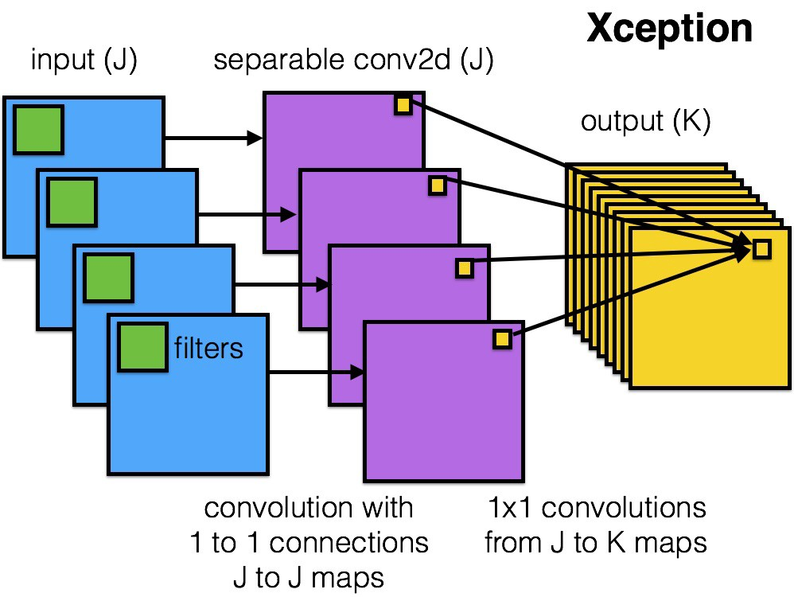

**Fig 3.1: XceptionNet Architecture**

**3.3 Explainable AI (XAI):**

Explainable AI (XAI) techniques, such as the Grad-CAM model, provide invaluable insights into the decision-making process of complex machine learning models, particularly deep neural networks. Grad-CAM, short for Gradient-weighted Class Activation Mapping, is a technique that produces visual explanations for model predictions by highlighting the regions of an input image that are most influential in the model's decision. By analyzing the gradient information flowing into the final convolutional layer of the model, Grad-CAM generates heatmaps that emphasize the areas where the model focuses its attention when making predictions. These heatmaps offer transparency and interpretability, enabling users to understand the rationale behind the model's outputs and aiding in decision-making processes. In applications such as medical diagnosis or autonomous driving, where model predictions have significant real-world consequences, Grad-CAM provides clinicians, engineers, and end-users with actionable insights, allowing them to trust and validate the model's decisions effectively. Additionally, Grad-CAM facilitates model debugging and refinement by identifying potential weaknesses or biases in the model's learned representations, ultimately contributing to the development of more robust and trustworthy AI systems.

The Grad-CAM technique computes the class-specific importance weights for each feature map in the final convolutional layer of a CNN. These weights are then used to generate a heatmap highlighting the regions of the input image that contributed most to the model's prediction for a specific class. Here are the equations involved:

* **Class Activation Map (CAM):**

The CAM is computed as the global average pooling of the gradients of the output score Yc with respect to the feature maps Ak of the last convolutional layer.

**(1)**

Equation 3.1: CAM computing equation

Where:

is the CAM for class c

represents the importance weight for feature map k corresponding to class c.

Ak denotes the feature map obtained from the last convolutional layer.

* **Importance Weights ​:**

**The importance weights ​ are computed by taking the global average pooling of the gradients of the output score *Yc* with respect to the feature maps *Ak*.**

**(2)**

**Equation 3.2: Importance weights** computing equation

**Where:**

***Z*** is the normalization factor.

**represents the gradient of the output score *Yc* with respect to the activations of the feature map *Ak* at position *(i,j)*.**

* **Heatmap​ :**

**The Grad-CAM heatmap is obtained by rectifying the CAM using the ReLU activation function.**

**(3)**

**Equation 3.3: Heatmap** computing equation

# This heatmap visually highlights the regions in the input image that are most relevant for predicting class *c*, providing interpretability and transparency into the model's decision-making process.

# These equations collectively form the basis of the Grad-CAM technique, enabling transparent visualization of deep neural network predictions and facilitating interpretability in AI systems.

**3.4 Performance Metrics:**

**3.4.1 Confusion Matrix:**

**A confusion matrix is a table used in machine learning and statistics to evaluate the performance of a classification algorithm. It is particularly useful for summarizing the results of a binary classification problem, where the output can be categorized into two classes, typically labeled as positive and negative.**

**The confusion matrix organizes the model's predictions and the actual outcomes into a 2x2 matrix which is shown in Fig 3.2. The four cells of the matrix represent different scenarios:**

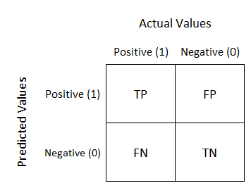

Fig 3.2: Confusion Matrix Diagram

Here's a breakdown of the elements:

* **True Positive (TP):** The instances that are actually positive and are correctly predicted as positive by the model.
* **True Negative (TN):** The instances that are actually negative and are correctly predicted as negative by the model.
* **False Positive (FP):** The instances that are actually negative but are incorrectly predicted as positive by the model. (Type I error)
* **False Negative (FN):** The instances that are actually positive but are incorrectly predicted as negative by the model. (Type II error)

**3.4.2 Accuracy:**

**Accuracy, in the context of a confusion matrix, is a performance metric that assesses the overall correctness of a classification model. The confusion matrix is a table that provides a detailed breakdown of the model's predictions, distinguishing between true positive (TP), true negative (TN), false positive (FP), and false negative (FN) instances.**

**Accuracy is calculated using the following formula:**

**Accuracy = (4)**

**Equation 3.4: Accuracy** computing equation

**3.4.3 Specificity:**

**Specificity, in the context of a confusion matrix, is a performance metric that focuses on the ability of a classification model to correctly identify the true negatives (TN) out of all actual negatives. It is also known as the true negative rate or the specificity rate. The specificity is calculated using the following formula:**

**Specificity = (5)**

**Equation 3.5: Specificity** computing equation

**3.4.4 Sensitivity:**

**Sensitivity, also known as recall or true positive rate, is a performance metric in the context of a confusion matrix that assesses a classification model's ability to correctly identify positive instances out of all actual positives. The sensitivity is calculated using the following formula:**

**Sensitivity = (6)**

**Equation 3.6: Sensitivity** computing equation

**3.4.5 ROC curve**

A Receiver Operating Characteristic (ROC) curve is a graphical representation that illustrates the diagnostic ability of a binary classification model across various threshold settings. It is a common tool used in machine learning and statistics to assess the trade-off between the true positive rate (sensitivity) and false positive rate (1 - specificity).

The ROC curve is created by plotting the true positive rate (TPR) on the y-axis against the false positive rate (FPR) on the x-axis at different threshold values. Each point on the ROC curve represents a different trade-off between sensitivity and specificity. A diagonal line (the line of no-discrimination) is often used as a reference, and points above this line indicate better-than-random classification.

Key concepts related to the ROC curve:

* **True Positive Rate (Sensitivity):**

**(7)**

**Equation 3.7: True positive rate** computing equation

* **False Positive Rate (1 - Specificity):**

**(8)**

**Equation 3.8: False positive rate** computing equation

**CHAPTER 4**

**METHODOLOGY**

The Section deals on the methodology and the flow steps to develop the model for working purpose. Developing an Automated model for predicting skin abnormalities from photographic images involves the integration of various technologies. Here are some key components and technologies commonly used for such applications:

**4.1 Data Collection:**

The dataset utilized in this project was sourced from Kaggle, a prominent platform for data science and machine learning resources. This dataset is specifically structured to facilitate the training and evaluation of the AI model for predicting high-risk skin abnormalities. The dataset comprises distinct classes of skin lesions, categorizing them into benign and malignant classes. This dichotomy enables the model to discern between non-threatening and potentially hazardous skin conditions, enhancing its diagnostic capabilities. The training subset of the dataset serves as the foundation for the model to learn the intricate patterns and features associated with benign and malignant skin abnormalities. Subsequently, the testing subset offers a rigorous evaluation framework, allowing for the assessment of the model's performance on unseen data. The inclusion of both benign and malignant classes from Kaggle ensures a comprehensive and balanced representation, fostering the development of a reliable and accurate AI-based mobile application for predicting high-risk skin abnormalities. Fig 4.1 and Fig 4.2 refers to the images contain on the dataset.

**Dataset link:** [**https://www.kaggle.com/datasets/fanconic/skin-cancer-malignant-vs-benign**](https://www.kaggle.com/datasets/fanconic/skin-cancer-malignant-vs-benign)

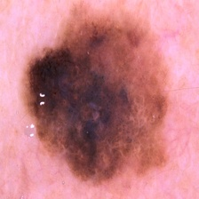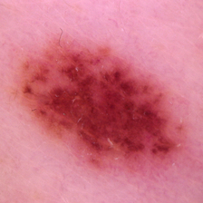

Fig 4.1: Benign ImageFig 4.2: Malignant Image

**4.2 Data Augmentation:**

Data augmentation is a critical technique employed in machine learning to enhance the diversity and quality of training datasets. In the context of developing an AI-based mobile app for predicting high-risk skin abnormalities from photographic images, data augmentation plays a pivotal role in improving the robustness and performance of the deep learning model. This process involves applying various transformations to existing images, such as rotations, flips, scaling, changes in brightness, and other distortions, thereby artificially expanding the dataset. By doing so, data augmentation addresses challenges associated with limited training data, enabling the model to learn more generalized and representative features. In the medical domain, where datasets can be scarce and imbalanced, data augmentation becomes particularly valuable. It aids in creating synthetic examples of minority classes, such as malignant skin abnormalities, contributing to a more balanced and comprehensive training set. The augmentation process not only increases the dataset size but also enhances the model's ability to handle variations in image quality, lighting conditions, and angles, ensuring improved performance and generalization when faced with diverse user-submitted images in the mobile application. After the data augmentation the total number of the images on the dataset is 17297. Examples of some augmented images are shown in Fig 4.3

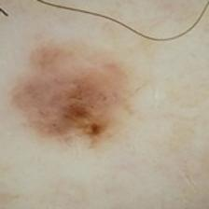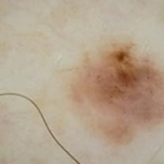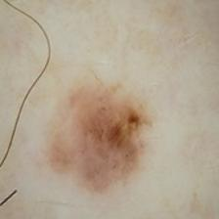

Fig 4.3: Augmented Images

**4.3 Model Implementation:**

The implementation of a high and low-risk skin cancer detection system using a transfer learning model like XceptionNet and explainable AI (XAI) Grad-CAM model involves several key steps. Initially, a diverse dataset of annotated skin lesion images, categorized into high and low-risk groups, is collected and preprocessed to ensure uniformity and quality. The XceptionNet model is then utilized, leveraging transfer learning by fine-tuning the pre-trained model on the skin cancer dataset to adapt it to the specific task of classification. Concurrently, the Grad-CAM model is integrated into the system to provide interpretable insights into the XceptionNet's decision-making process, generating heatmaps that highlight the regions of the skin lesions most influential in the model's predictions. These heatmaps offer transparency and assist clinicians in understanding the rationale behind the model's outputs, aiding in diagnosis and decision-making. The implemented system is rigorously evaluated using metrics such as accuracy, precision, recall, and F1-score to assess its performance in detecting both high and low-risk skin cancers. Through this comprehensive approach, combining advanced machine learning techniques with transparent and interpretable AI methods, the implemented system aims to provide a reliable and effective tool for skin cancer detection, ultimately improving patient outcomes and healthcare decision-making.

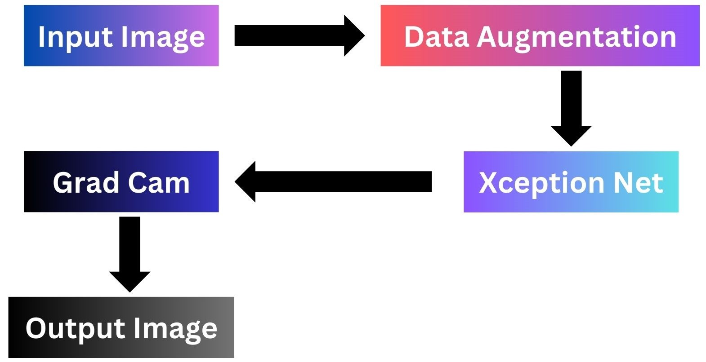

Fig 4.4: Block Diagram of the Model

**CHAPTER 5**

**OUTPUT**

This Section intends to discuss the result of the prediction model. In order to achieve the objectives of this chapter, we have executed several experiments i.e. validation of the model using 80/20, 70/30 and 60/40 training/testing proportions a 5-fold cross validation is also executed to achieve the desired accuracy of the model. For this project total three deep learning models are implemented on the dataset and from which XceptionNet provides best result.

**5.1 Visual verification of the predicted results:**

Visual verification of the predicted results is refer to Fig 5.4 where low risk is taken as negative and high risk is taken as positive

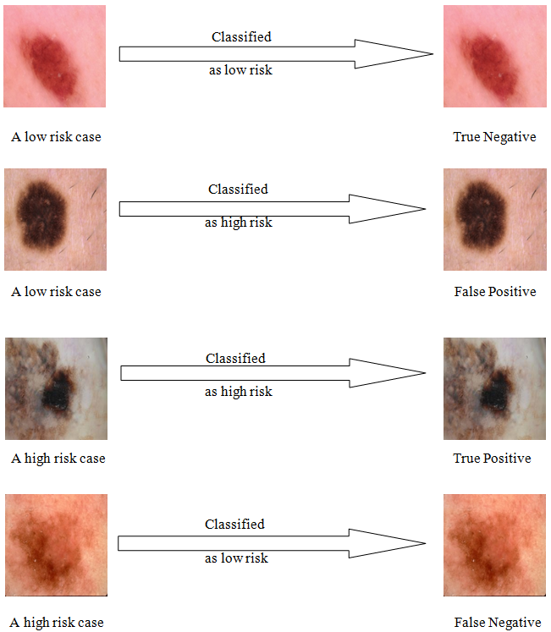



Fig 5.1: Visual verification of the predicted results

**5.2 Performance Analysis:**

Table 5.1: Performance Analysis of different models on 80/20 dataset

|  |  |  |  |
| --- | --- | --- | --- |
| **Analysis on 80/20 dataset** | **XceptionNet** | **CNN** | **MobileNet V2** |
| **Accuracy (%)** | 91.07 | 84.19 | 51.56 |
| **Sensitivity (%)** | 90.07 | 82.25 | 46.13 |
| **Specificity (%)** | 91.71 | 80.47 | 43.57 |

Xception model is implemented on the 80/20 dataset using transfer learning through imagenet and its gives the best accuracy approximately 91.07%.

Table 5.2: Performance Analysis of XceptionNet model on dataset

|  |  |  |  |
| --- | --- | --- | --- |
| **XceptionNet Performance** | **80/20** | **70/30** | **60/40** |
| **Accuracy (%)** | 91.07 | 86.15 | 78.65 |
| **Sensitivity (%)** | 90.07 | 73.25 | 47.38 |
| **Specificity (%)** | 91.71 | 70.47 | 52.57 |

The Confusion Matrix and the ROC Curve of the XceptionNet model at 80/20 dataset are referred to Fig 5.1 and Fig 5.2 respectively.

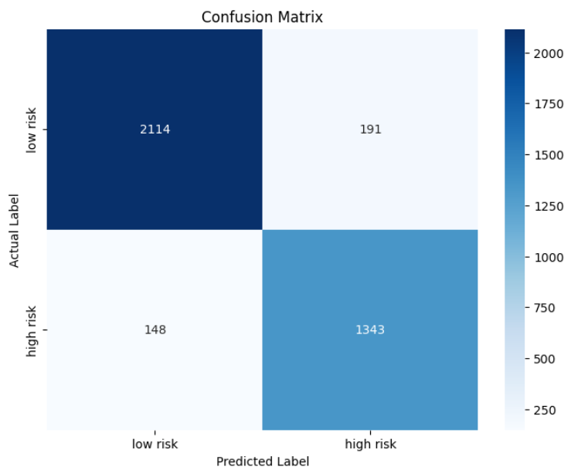

Fig 5.2: Confusion Matrix of Xception Net model on 80/20 Dataset

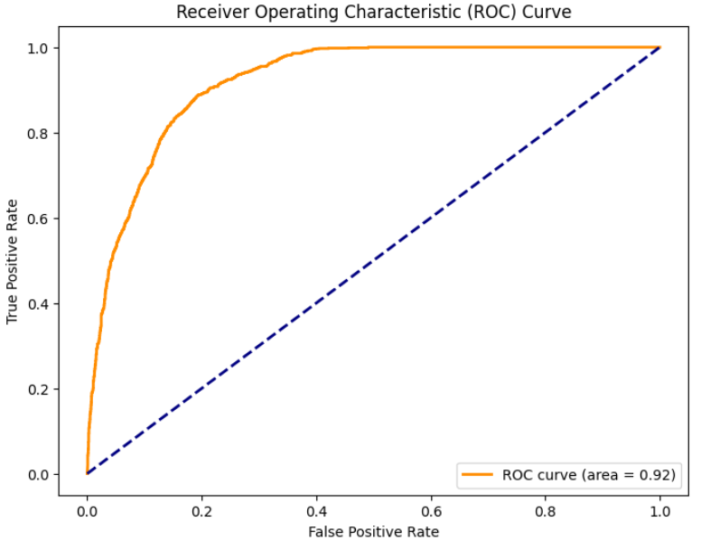

Fig 5.3: ROC Curve of XceptionNet model on 80/20 Dataset

A Receiver Operating Characteristic (ROC) curve with an AUC of 0.92 refer to Fig 5.2 indicates a highly accurate classifier. This means the classifier excels at discriminating between positive and negative cases, accurately identifying both. The ROC curve itself likely exhibits a steep rise, suggesting even minor adjustments to the decision threshold can significantly enhance true positive rate while keeping false positive rate low. While such performance is already impressive, further analysis of the ROC curve and other metrics can identify areas for optimization and refine the model further.

In conclusion, an AUC of 0.92 signifies a robust classifier with exceptional discriminatory power. However, continuous evaluation and optimization remain crucial for maximizing its effectiveness in real-world applications.

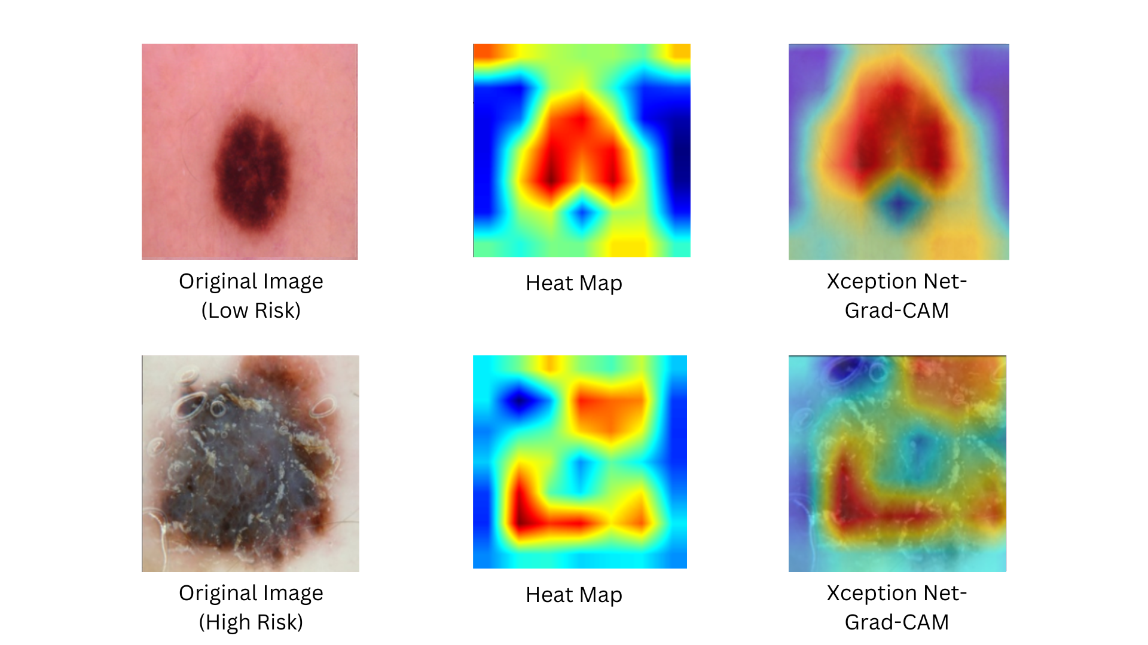

Fig 5.4: Results of Grad-CAM

From Fig 5.3 colors in the heatmap like red, yellow, light green, and blue are important for highlighting areas and differentiating between growths that are potentially high and low risk for skin cancer detection. Red usually denotes high-risk areas, suggesting possible cancer from elevated blood flow or inflammation. Yellow indicates cellular alterations or precancerous lesions, which would be of moderate concern. To help in the comparison with potentially anomalous areas, light green is used as a reference for normal skin. Blue, on the other hand, denotes areas of normalcy or low worry, which helps to distinguish between possible lesions and healthy skin. By combining these hues, dermatologists and other medical professionals can immediately identify and prioritize locations for additional investigation, leading to a more accurate and efficient diagnosis of skin cancer.

**CONCLUSION**

In conclusion, the integration of transfer learning with the XceptionNet model and explainable AI (XAI) techniques such as Grad-CAM represents a significant advancement in the field of high and low-risk skin cancer detection. Through the utilization of a diverse dataset and the fine-tuning of a pre-trained XceptionNet model, the system demonstrates a high level of accuracy and reliability in classifying skin lesions into different risk categories. Moreover, the incorporation of Grad-CAM provides valuable insights into the model's decision-making process, enhancing transparency and interpretability for clinicians and healthcare professionals. By generating heatmaps that highlight the regions of interest within skin lesion images, Grad-CAM facilitates informed diagnostic assessments, ultimately leading to improved patient care and treatment outcomes. The implemented system offers a comprehensive and effective approach to skin cancer detection, leveraging cutting-edge machine learning algorithms and transparent AI methods to address a critical healthcare challenge. As research and technology continue to advance in this area, such integrated systems hold promise for revolutionizing the early detection and management of skin cancer, thereby saving lives and enhancing the quality of healthcare delivery.

**FUTURE WORK**

Moving forward, the logical progression involves the development of a user-friendly mobile application for high and low-risk skin cancer detection, leveraging the power of transfer learning with the XceptionNet model and explainable AI (XAI) Grad-CAM model. Such an app would democratize access to advanced skin cancer detection capabilities, empowering users to perform self-assessments and seek timely medical intervention when necessary. The user interface will be designed to be intuitive and straightforward, allowing users to upload images of skin lesions effortlessly and receive instant feedback on their risk level. The app will utilize the pre-trained XceptionNet model for accurate classification and integrate Grad-CAM for transparent visualization of the model's decision-making process, ensuring users can understand and trust the results. Additionally, the app could feature educational resources on skin cancer prevention and early detection, further promoting awareness and proactive healthcare practices. Through iterative testing and user feedback, the app can be refined to meet the specific needs and preferences of its target audience, ultimately serving as a valuable tool in the fight against skin cancer on a global scale.

**REFERENCE**

[1] M. Vidya and M. V. Karki, “Skin cancer detection using machine learning techniques,” 2020 IEEE International Conference on Electronics, Computing and Communication Technologies (CONECCT), 2020. doi:10.1109/conecct50063.2020.9198489

[2] M. S. Akter, H. Shahriar, S. Sneha, and A. Cuzzocrea, “Multi-class skin cancer classification architecture based on Deep Convolutional Neural Network,” 2022 IEEE International Conference on Big Data (Big Data), 2022. doi:10.1109/bigdata55660.2022.10020302

[3] Md. K. Islam et al., “Melanoma skin lesions classification using deep convolutional neural network with transfer learning,” 2021 1st International Conference on Artificial Intelligence and Data Analytics (CAIDA), 2021. doi:10.1109/caida51941.2021.9425117

[4] A. Lembhe, P. Motarwar, R. Patil, and S. Elias, “Enhancement in skin cancer detection using image super resolution and Convolutional Neural Network,” Procedia Computer Science, vol. 218, pp. 164–173, 2023. doi:10.1016/j.procs.2022.12.412

[5] R. Mahum and S. Aladhadh, “Skin lesion detection using hand-crafted and DL-based features fusion and LSTM,” Diagnostics, vol. 12, no. 12, p. 2974, 2022. doi:10.3390/diagnostics12122974

[6]Mehmet Baygin, undefined. Turker Tuncer, undefined. Sengul Dogan, "New pyramidal hybrid textural and deep features based automatic skin cancer classification model: Ensemble DarkNet and textural feature extractor," 2022.

[7] H. Nahata and S. P. Singh, “Deep Learning Solutions for skin cancer detection and diagnosis,” Learning and Analytics in Intelligent Systems, pp. 159–182, 2020. doi:10.1007/978-3-030-40850-3_8

[8] J. Daghrir, L. Tlig, M. Bouchouicha, and M. Sayadi, “Melanoma skin cancer detection using deep learning and classical machine learning techniques: A hybrid approach,” 2020 5th International Conference on Advanced Technologies for Signal and Image Processing (ATSIP), 2020. doi:10.1109/atsip49331.2020.9231544

[9] K. M. Hosny, M. A. Kassem, and M. M. Foaud, “Skin cancer classification using Deep Learning and Transfer Learning,” 2018 9th Cairo International Biomedical Engineering Conference (CIBEC), 2018. doi:10.1109/cibec.2018.8641762

[10] T. Y. Tan, L. Zhang, and C. P. Lim, “Intelligent skin cancer diagnosis using improved particle swarm optimization and deep learning models,” Applied Soft Computing, vol. 84, p. 105725, 2019. doi:10.1016/j.asoc.2019.105725

[11] M. Nawaz et al., “Skin cancer detection from dermoscopic images using deep learning and fuzzy k‐means clustering,” Microscopy Research and Technique, vol. 85, no. 1, pp. 339–351, 2021. doi:10.1002/jemt.23908

**PLAGARISM REPORT**

